**NITRO Clubs EU**

**IT Robo Olympics**

**Robot Remote Control**

**COMPETITION**

**APPENDIX A: OBSTACLE COURSE LAYOUT**

**APPENDIX A: OBSTACLE COURSE LAYOUT**

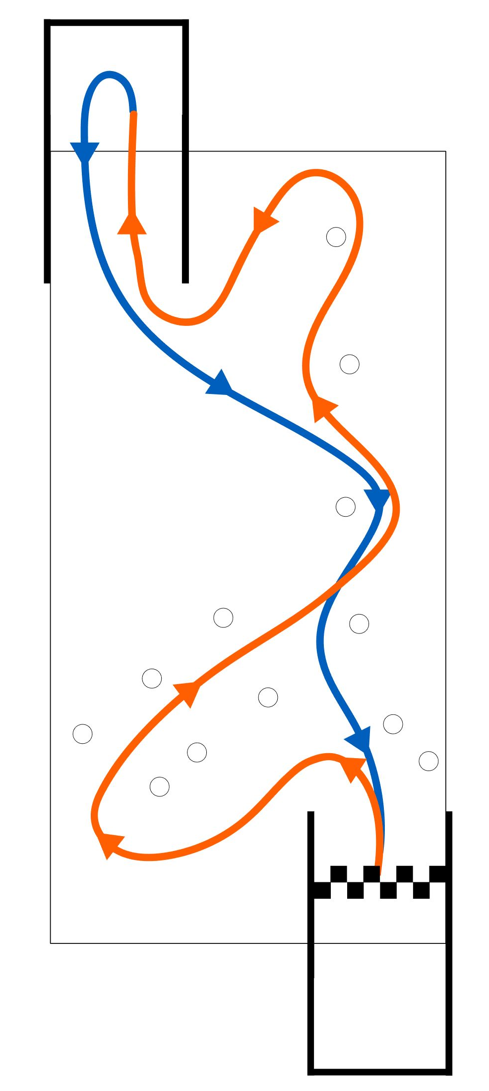

Fig.1 Path to follow on the obstacle course for robot teleoperation.

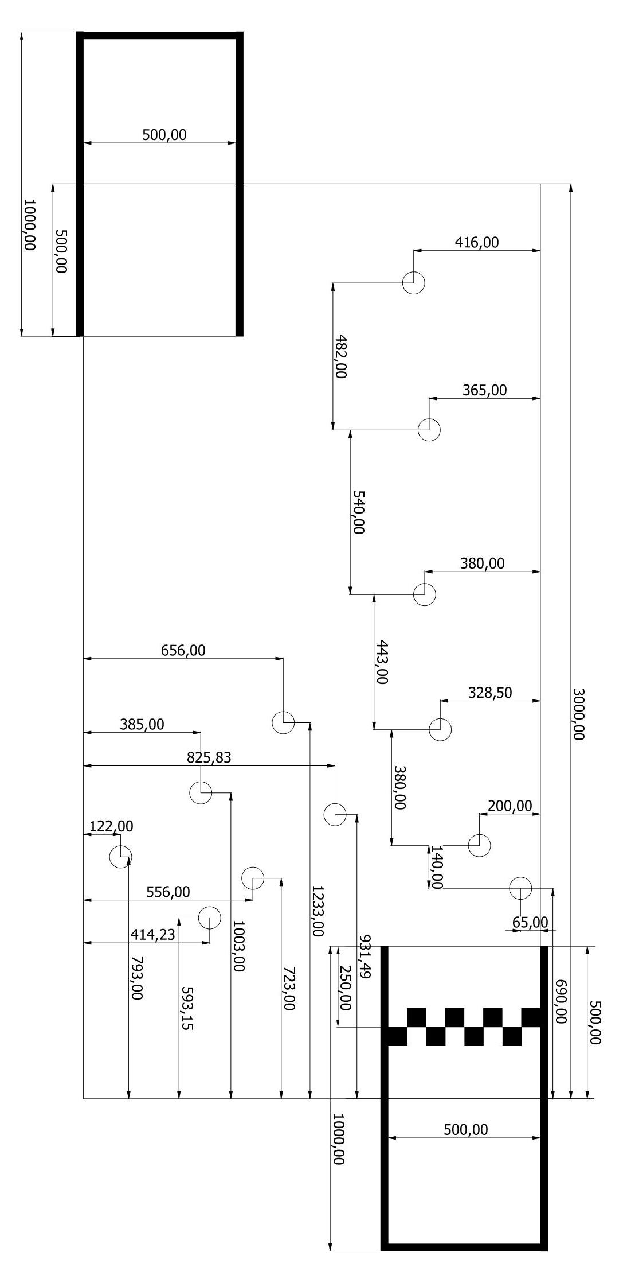

Fig. 2 Layout of the obstacle course for robot teleoperation.